Tool Guide – John The Ripper

Introduction
John the Ripper (JTR) is a tool used to find weak passwords. It works by trying many possible passwords very quickly until it finds the correct one. In cybersecurity, this helps testers see if a password is too easy to guess, so it can be changed to something stronger. JTR can work with many types of password formats, like MD5, SHA1, or NTLM, and can use different methods like wordlists (trying common passwords) or brute force (trying all possible combinations).
In the Deakin Detonator Toolkit (DDT), John the Ripper is made simple to use through a friendly interface, so beginners can learn how password cracking works in a safe environment.
Safety Disclaimer: Only use this tool on systems and files you own or have permission to test. Cracking passwords without permission is illegal and against university rules.

Setup and Launch
Step 1: Open Deakin Detonator Toolkit
- Launch Terminal in your Kali Linux or other supported Linux environment.
- Navigate to the directory where the Deakin Detonator Toolkit is located:
cd ~/Deakin-Detonator-Toolkit
- Start the toolkit using the command:
yarn run tauri dev

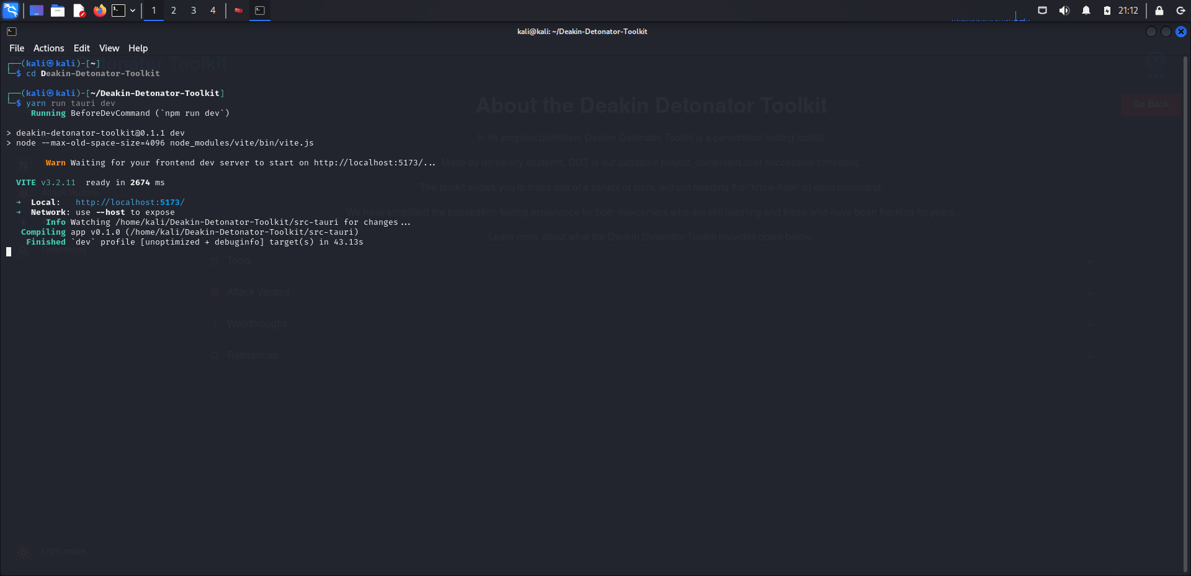
- This will launch the main interface of the toolkit.

Step 2: Locate the Tool
- Click on “Tools” from the left-hand side menu or use the search bar.
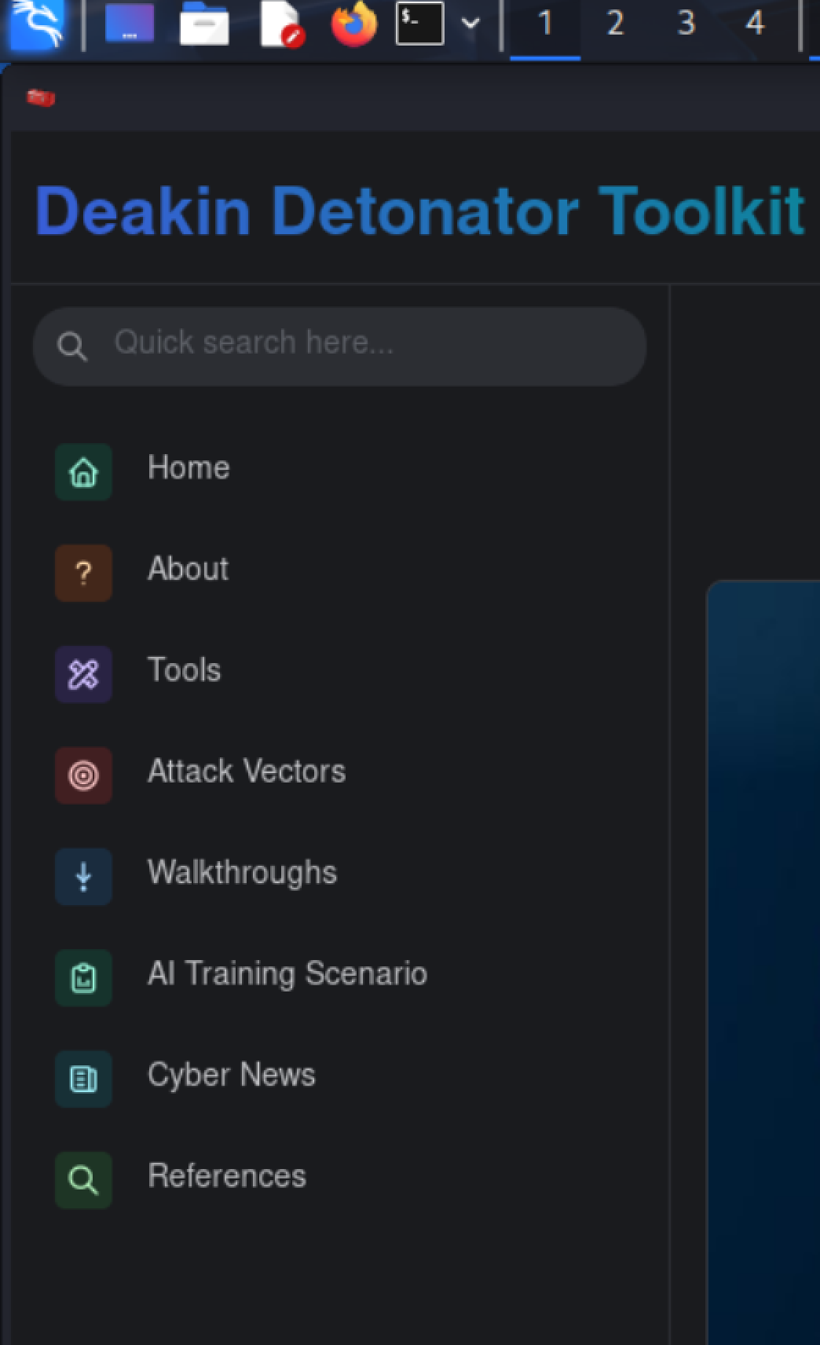
- Look for JohnTheRipper under Password Cracking and Authentication Testing category.
- Click the blue “Go” button next to the tool name to open it.
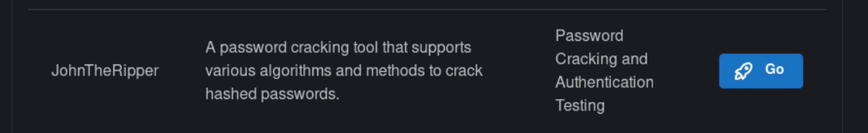

Step 3. Configuration
Configuration Tab Fields:

Setting | Description | Example
File Path | Path to the file containing hashes/passwords to crack. | /home/kali/secret.txt
Crack Mode | Method used to crack passwords. Options include Dictionary, Brute-force, and Hybrid. | Dictionary
Wordlist Path (if Dictionary Mode) | File path to the wordlist. | /usr/share/wordlists/rockyou.txt
Hash Type | Format of the hash being cracked. | MD5, SHA512, NTLM

Crack Mode Explanations:
- Dictionary Mode: Uses a predefined list of possible passwords (wordlist) and tries each one against the hash. This is faster if you expect the password to be a common word or phrase. In this example, we are using Dictionary Mode.
- Brute-force Mode: Tries every possible combination of characters until the correct password is found. This is the most thorough but also the slowest method.
- Hybrid Mode: Combines dictionary and brute-force methods. It starts with a wordlist and then modifies each word (e.g., adding numbers or symbols) to expand the chances of finding a match.
Flags & Functions:
- --show – Displays all cracked passwords from previous sessions.
- --format – Specifies the hash type.
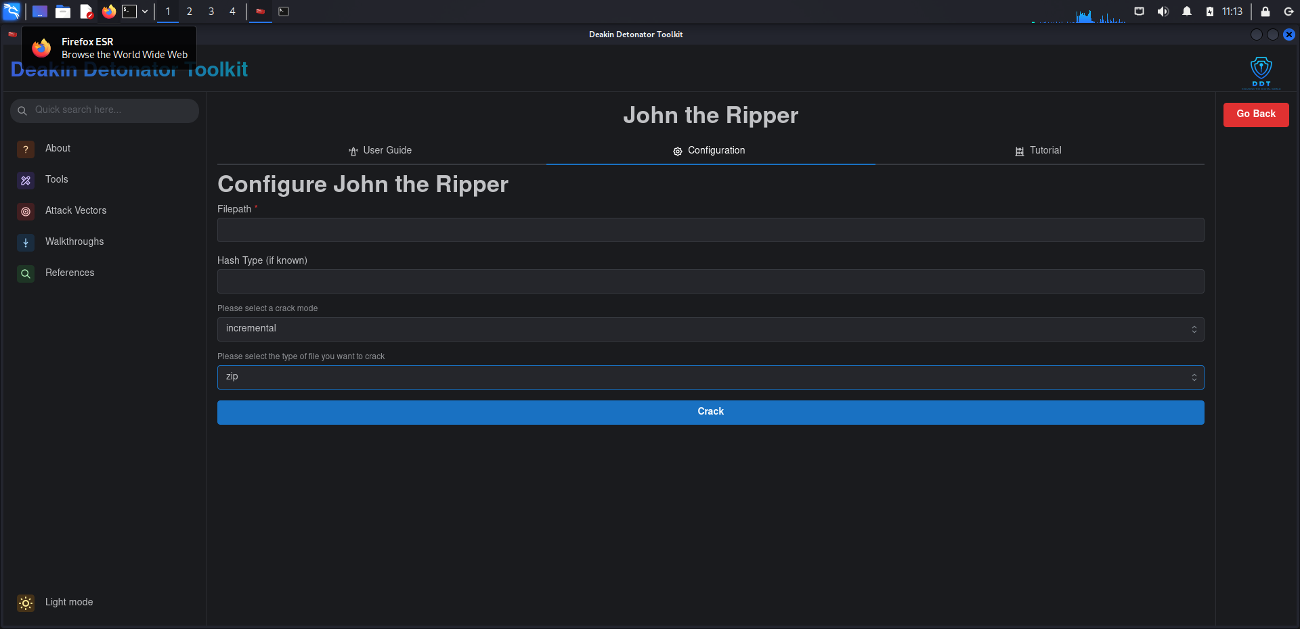

Tool Usage
Example – Cracking a hash with a wordlist
- Enter file path: /home/kali/secret.txt
- Select Dictionary Mode.
- Enter wordlist path: /usr/share/wordlists/rockyou.txt
- Select hash type: MD5
- Click Start.
JTR will attempt each word from the wordlist against the hash until a match is found.
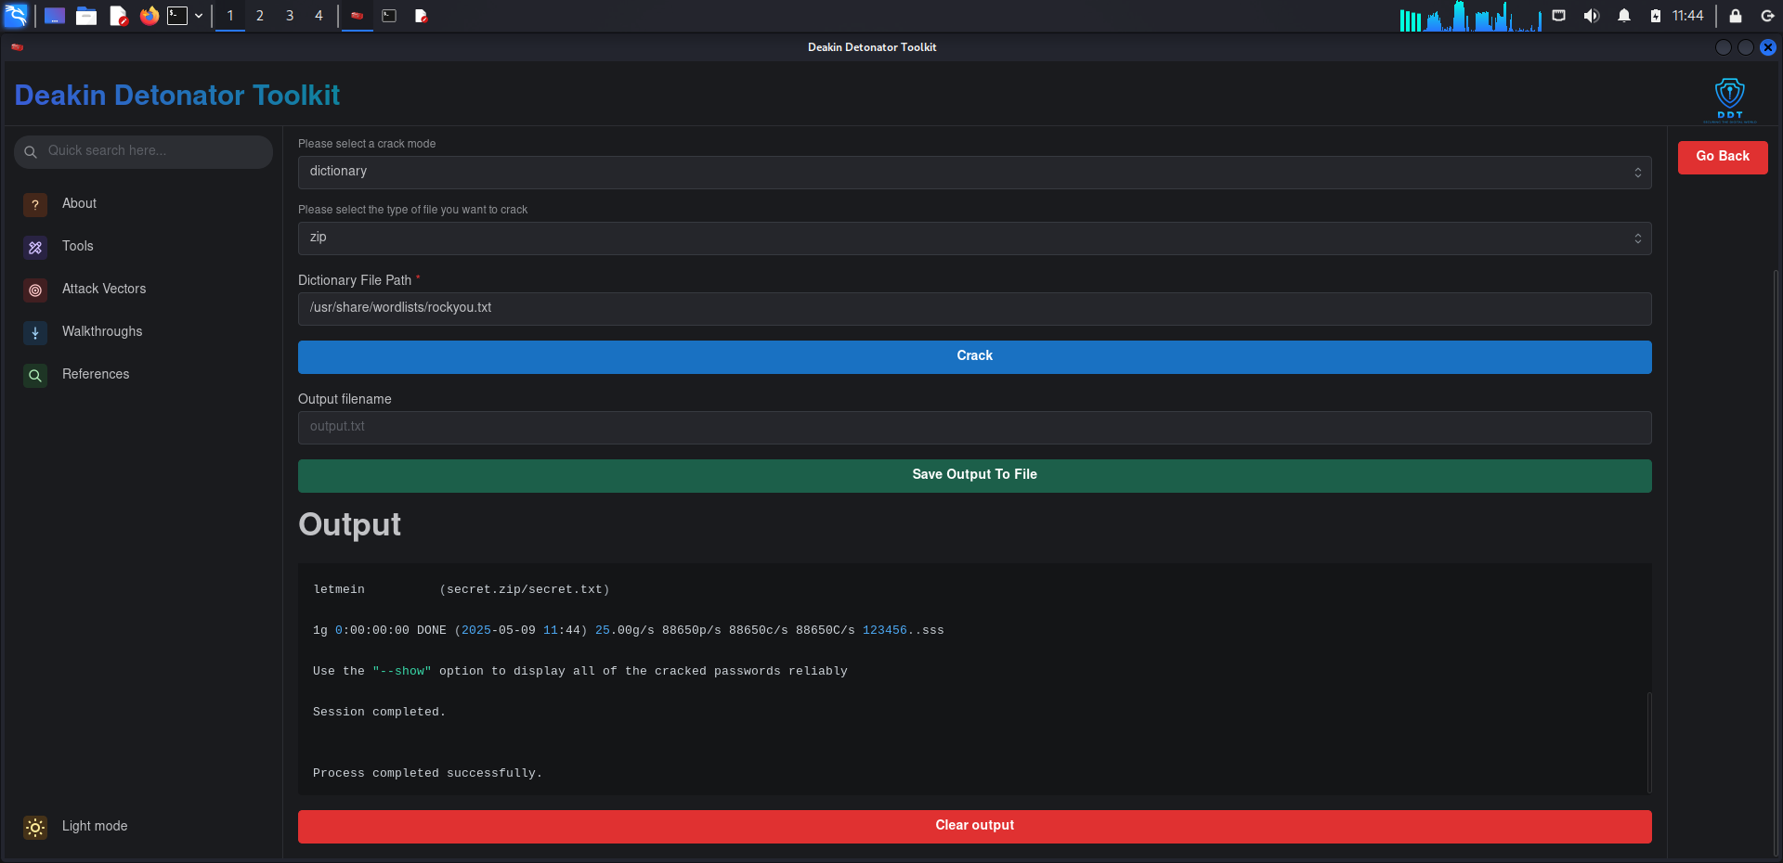

Output & Interpretation
Typical output fields:
- Cracked Password – The recovered password (e.g., letmein).
- Associated File – The file where the password is used (secret.zip).
- Performance Stats – Passwords tested per second.
- Session Status – Confirms successful completion.


Troubleshooting & Visuals
Common Issues & Fixes:
- "No password hashes loaded" – Ensure file format matches the selected hash type.
- Slow cracking speed – Use optimized wordlists or specify hash format.
- Permission Denied – Run with superuser privileges if required.

